**Abstract:**

Travelling is one of the greatest experiences which makes the human learn many skills, experience emotions of others in the life. In this project we have proposed a system which helps the tourist to travel easily by giving the experience of our MERN-based travel website DELVE. The system consists of features like posting pictures on which other users can give a like and comment on it.

The key feature of our system is recommending the Itinerary of the tourist places to visit at a low cost and in less time. Another one is that the system provides the best deal to the user to travel to their favorite places. And the most important is a review of the tourist places which makes the system more efficient to recommend the user to travel.

**Introduction:**

Touring and Travelling is adored by many people. It is a popular leisure activity. Planning is a challenging and tedious task. People who are unfamiliar with this can find this process exhausting. Planning involves deciding a preliminary and completion date of the trip, accommodation, places to visit, and most importantly budget. One needs to have a proper idea about every aspect in-order to plan a perfect trip. All this is taken care by Delve. Delve is a combination of Itinerary Generation integrated with social media. Any user can plan a perfect trip by just giving their requirement along with some basic information and will get the best possible itinerary in-terms of travelling, accommodations, Point of Interest[POI], and most importantly best deals. Social Media benefits in increasing the quality of trip by providing an opportunity to communicate with people near you and also allows you to get a gist of location you will be visiting.

**Literature Review**

**Title:** Efficient itinerary recommendation via personalized POI selection and pruning.

**Authors:** Sajal Halder · Kwan Hui Lim · Jeffrey Chan · Xiuzhen Zhang

**Abstract:** Personalized itinerary recommendation has garnered wide research interests for their ubiquitous applications. Recommending personalized itineraries is complex because of the large number of points of interest (POI) to consider in order to construct an itinerary based on visitors’ interest and preference, time budget and uncertain queuing time. This Paper defines the personalized itinerary recommendation problem, with the main objectives of maximizing the popularity, visitor interest, visiting time of each POI visited/recommended and minimizing the queuing and travel times.

**Approach:** [1]. Personalized itinerary recommendation has garnered wide research interests for their ubiquitous applications. The Paper defines the personalized popularity, visitor interest, visiting time of each POI visited/recommended and minimizing the queuing and travel times.

**Keywords:** Itinerary recommendation · Personalization · Points of interest · Queuing time · Search pruning · Monte Carlo tree search**.**

**Title:** Research on the Construction of Tourism Information Sharing Service Platform and the Collection of Tourist Satisfaction.

**Authors:** Huiwei Su · Xuanmiao Lin · QixiuXie4 · Wuxiang Chen · Yuanbin Tang.

**Abstract:** Through the big data technology architecture, a tourism information sharing service platform with tourism data collection, sharing standards and data collaboration functions enables the platform to have functions such as tourist gathering monitoring and early warning system, tourist smart travel app, and tourist satisfaction collection and analysis. Make greater efforts to achieve big data to promote better development of tourism.

**Approach:** [2]. Proposes a platform with tourism data collection, sharing standards and data collaboration functions such as tourist gathering, monitoring and tourist satisfaction collection and analysis.

**Keywords:** Tourism big data; data sharing; Data mining; Tourist satisfaction Tourism monitoring

**Title:** Development of Tourism Information System using Content-Based Filtering

**Authors:** Ron Astle · Lobo Shridhar · Suresh Bhat · J Shesha Shankar.

**Abstract:** Tourism in Karnataka is scattered all over the web. There is no centralized system to provide necessary information for tourists. Tourists also face the problem of local language. Our proposed system is a centralized system based on Android that provides all necessary information for the tourists to organize a successful trip. The proposed system is implemented and tested to serve all types of travellers.

**Approach:** [3] Is an app which includes an itinerary of your travel that will help the user plan what they want to cover in their duration with an Interactive Chatbot for assistance.

**Keywords:** Tourism Information System, Android Application, Firebase, Data Mining.

**Title:** Travel Itinerary Recommendations with Must-see Points-of-Interest

**Authors:** Kendall Taylor · Kwan Hui Lim · Jeffrey Chan.

**Abstract:** Travelling and touring are popular leisure activities enjoyed by millions of tourists around the world. However, the task of travel itinerary recommendation and planning is tedious and challenging for tourists, who are often unfamiliar with the various Points-ofInterest (POIs) in a city. Apart from identifying popular POIs, the tourist needs to construct a travel itinerary comprising a subset of these POIs, and to order these POIs as a sequence of visits that can be completed within his/her available touring time. For a more realistic itinerary, the tourist also has to account for travelling time between POIs and visiting times at individual POIs. Furthermore, this itinerary should incorporate tourist preferences such as desired starting and ending POIs (e.g., POIs that are near the tourist’s hotel) and a subset of must-see POIs (e.g., popular POIs that a tourist must visit).

**Approach:** [4]. Proposes an Itinerary which take account of personalized inputs from the user regarding any Point-Of-Interest(POI) and include it in the generated itinerary using LP+M algorithm.

**Keywords:** Tourism Information System, Android Application, Firebase, Data Mining.

**Our Approach**: Delve is a combination of Itinerary Generation integrated with social media. Any user can plan a perfect trip by just giving their requirement along with some basic information and will get the best possible itinerary in-terms of travelling, accommodations, Point of Interest[POI], and most importantly best deals. Each recommended place will have an overview and review section. Delve provides Robust User Authentication to protect any breach in confidentiality. Social Media benefits in increasing the quality of trip by providing an opportunity to communicate with people near you and also allows you to get a gist of location you will be visiting.

**Algorithm**

The Algorithm Implemented in this project is majorly based on 5 Modules namely (Input Module, Clustering Module, Recommendation Engine, Itinerary Generator & Social Media Timeline ), After User’s Data Collection The Selective Inferences are Made for the Clustering Module to Implement Agglomerative Clustering on these Inferences. After this Content based Filtering is Performed in the Recommendation Engine based on Certain Parameters with the Help of Tf-Idf Vectorizer & Cosine_Similarity which Generates Recommendations, Based on these Recommendations an user Specific Itinerary is Generated which also include Social Media Timeline in the form of Posts.

**Input Module:**

This is the Data Collection Module that takes inputs from the Individual users, once the user inputs are collected Selective Inference can be made for Tailored Outputs.

Some of the Parameters for Inputs are as follows:

* Approx Budget
* Start Date, End Date
* Month
* Going With (Family, Friends, Romantic, Solo)
* Interests (Adventure, Sightseeing, beaches, mountains)

**Clustering Module:**

This Algorithm Adopts Agglomerative Clustering which follows bottom-up approach. This clustering algorithm does not require us to prespecify the number of clusters. Bottom-up algorithms treat each data as a singleton cluster at the outset and then successively agglomerates pairs of clusters until all clusters have been merged into a single cluster that contains all data.

Clustering is performed based on the user’s POI (Point of Interest) which is collected in the previous phase i.e Input Module with the Destinations & Activities to be Performed there.

Equation: **D(r,s) = Trs / ( Nr * Ns)**

Where Trs is the sum of all pairwise distances between cluster r and cluster s. Nrand Ns are the sizes of the clusters r and s, respectively.

**Recommendation Engine**

The Recommender System is based on Content Based type of Filtering, the attributes used for this are as follows:

* Max_Cost, Min_Cost
* Max_Duration, Min_Duration
* Season
* Tags
* Activities Available (eg. Trekking, Swimming)

TfidfVectorizer: the purpose of using the TF-IDF vectorizer is to weigh the importance of each word taken as the input, TF-IDF vectorizer is a useful tool for converting text data into numerical features that is used in our Machine Learning Model.

Equation: **tf-idf(t, d) = tf(t, d) * idf(t)**, The idf is computed as **idf(t) = log [ n / df(t) ] + 1** where n is the total number of documents in the document set and df(t) is the document frequency of t.

Cosine_Similarity: The Purpose of using this is to map the degree of similarities from the data collected, for e.g POI chosen as Mountains the Destinations & the Activities to be Performed their will be compared & the parameters which has the highest degree of Similarity will be put in one Vector.

Equation: **Cos(x, y) = x . y / ||x|| * ||y||**

* x . y = product (dot) of the vectors ‘x’ and ‘y’.
* ||x|| and ||y|| = length of the two vectors ‘x’ and ‘y’.
* ||x|| * ||y|| = cross product of the two vectors ‘x’ and ‘y’.

The Output of this Module Generates URL, Destinations, Activities Available.

**Itinerary Generator.**

Based on Clustering of POI & Output from the Recommendation Engine the Itinerary will be generated According to the days, time & Activities one should perform their.

**Social Media Timeline.**

Based on the Generated Itinerary, Social Media Posts which contains Images, Comments, & Reviews of these places is Displayed to the user.

**Project Explanation / Implementation Details**

Delve is a combination of Personalized Itinerary Generator amalgamated with social media. Any user can plan a perfect trip by suggesting their requirements along with some basic information and will get the best possible itinerary in-terms of traveling, accommodations, Point of Interest[POI], and most importantly best deals. Social Media benefits in improving the quality of trip by providing an opportunity to communicate with people near you and also allows you to get a summarized gist of the location you will be visiting. This Project is Developed using Redux Implementation of MERN stack.

The Project is Basically divided into 3 modules namely: Social Media, Itinerary Generator & Best Deals.

As mentioned above Delve is Implemented in the MERN stack (MongoDB, Express.js, React.js, Node.js) Coupled with a Machine Learning Model for Itinerary Generation.

Let’s See Implementation of Each of these Modules in detail.

1. **Social Media**: It contains Features like Posting Reviews, Like, Comment, User Authentication with JWT & GoogleOAuth, and also Privileges Management in the Redux Store.

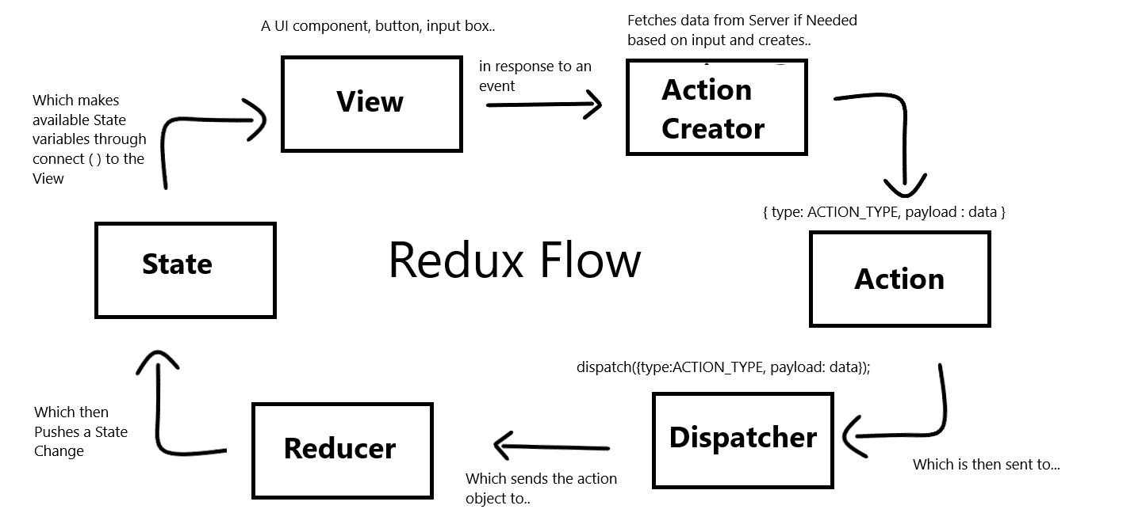

**JWT Authentication**

JWT authentication is a token-based stateless authentication mechanism. It is popularly used as a client-side-based stateless session, this means the server doesn’t have to completely rely on a data store (or) database to save session information.

JWTs can be encrypted, but they are typically encoded & signed. We will be focusing on Signed JWTs. The purpose of Signed JWT is not to hide the data but to ensure the authenticity of the data. And that is why it’s highly recommended to use HTTPS with Signed JWTs.

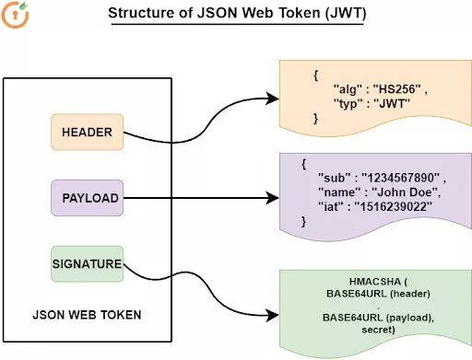

**Styles**

Styling of Entire Application is done using MaterialUI (MUI) for React.

Material UI is an open-source React component library that implements Google's Material Design.

It includes a comprehensive collection of prebuilt components that are ready for use in production right out of the box.

Material UI is beautiful by design and features a suite of customization options that make it easy to implement your own custom design system on top of our components.

1. **Itinerary Generator**: This Module is Entirely based on the Machine Learning Model, embedded to the React Components in our Application.

Model will Ask users for Various Parameters like Budget, Time, Personalized choices of Places & Many more things.

Based on these parameters our ML model will Generate a Personalized itinerary for the user from source to destination considering Personalized Points of Interest of the user.

The Output of this Model will be Displayed by the React Application using React Hooks & Python Middleware API.



1. **Best Deals**: These Modules will be able to WebScrape all the Top Websites like TravelAdvisor, MakeMyTrip, Agoda, TravellersPoint for the Given Locations & Top Deals will be Fetched - Compared and Shown to the user using Node.js Web Scraping.



**Conclusion: -**

Project Delve- MERN based application Embedded with Machine learning Model with many Robust libraries like Redux (Actions & Reducers), axios, cors, Itinerary generator, web scraping, JWT Authentication is Implemented to enable One Stop Solution for all the Trip Planners.